**DAILY ONLINE ACTIVITIES SUMMARY**

|  |  |  |  |  |  |  |  |  |
| --- | --- | --- | --- | --- | --- | --- | --- | --- |
| **Date:** | **23/05/2020** | | | | | **Name:** | **SPOORTI S DAROJI** | |
| **Sem & Sec** | **4th SEM. & ‘B’ SEC.** | | | | | **USN:** | **4AL18CS088** | |
| **Online Test Summary** | | | | | | | | |
| **Subject** | | **DATA COMMUNICATION** | | | | | | |
| **Max. Marks** | | **30** | | **Score** | | | **25** | |
| **Certification Course Summary** | | | | | | | | |
| **Course** | **Python for Machine Learning** | | | | | | | |
| **Certificate Provider** | | | **Greatlearning**  **academy** | | **Duration** | | | **5 Hrs.** |
| **Coding Challenges** | | | | | | | | |
| **Problem Statement 1: Write a C Program to generate first N Triangular Numbers (Where N is Read from the Keyboard).** | | | | | | | | |
| **Status: Executed.** | | | | | | | | |
| **Uploaded the report in Github** | | | | | **Yes** | | | |
| **If yes Repository name** | | | | | [alvas-education-foundation](https://github.com/alvas-education-foundation)/[spoorti_daroji](https://github.com/alvas-education-foundation/spoorti_daroji) | | | |
| **Uploaded the report in slack** | | | | | **Yes** | | | |

**Online Test Summary: 18CS46 test was scheduled from 9:15AM to 9:55AM.The Portion for the IA was 1st and 2nd module there were 30 questions of one mark & the time assigned was 40 minutes. The questions were mcq type.**

**Online Certification course Summary: In today’s session I have learnt about Functions,Other functions like LAMBDA which is an inline function.Special functions in python like Filter where we can’t compute anything within the filter it is only works on the boolean operator like where boolean it takes decision whether to filter out this particular element or not,will not be able to compute using filter function.**

**For computing we use a function called MAP which applies the condition for the individual entity of the sequence and stores out the output in the given list.As shown in the snapshot below.**

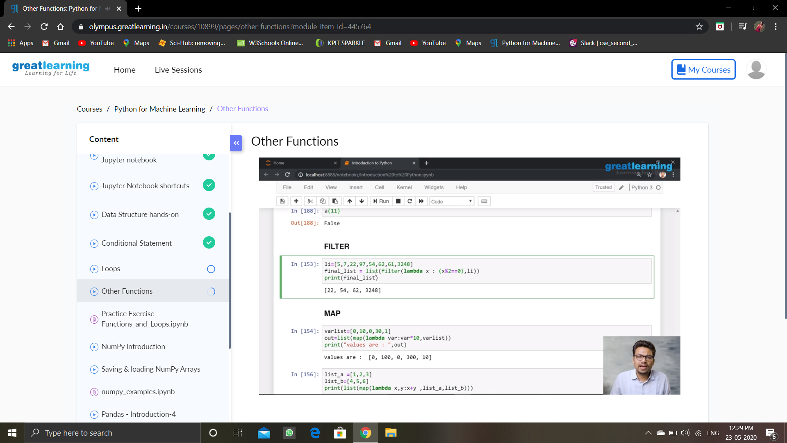

**Online Coding Summary: Today I received the program from prof.Venkatesh CSE Dept.**

**The program is mentioned above in the coding challenges.I have written a program and uploaded it to my Github repository.as shown in the below repository.**

